**LAB 03**

**NAME: SYEDA ALAINA.**

**ID.NO: BIT-23F-040.**

**SECTION: A.**

**SUBJECT: ARTIFICIAL INTELLIGENCE.**

**Lab Task 1:**

Simple ATM Machine Create a simple ATM program where the user has to enter a PIN to proceed.

● The correct PIN should be 1234.

● If the user enters the correct PIN, display a menu that allows the user to:

○ Check Balance (display a fixed balance, e.g., 1000).

○ Withdraw Money (ask the user how much they want to withdraw and deduct that amount from the balance).

● If the user enters an incorrect PIN, print "Incorrect PIN" and terminate the program.

**CODE:**

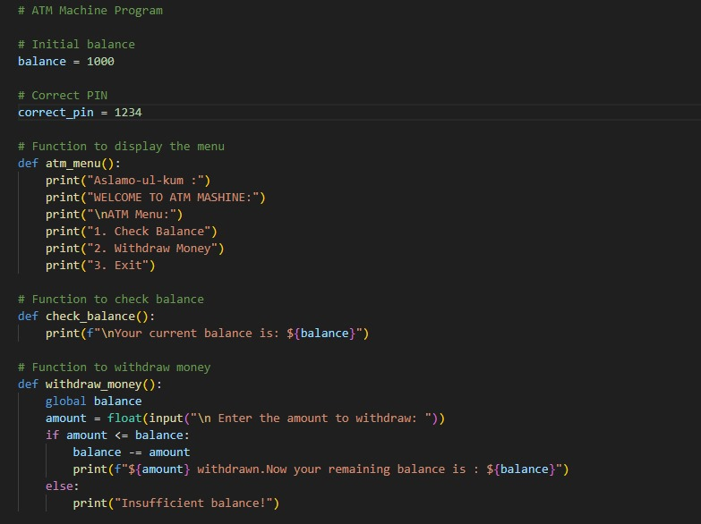

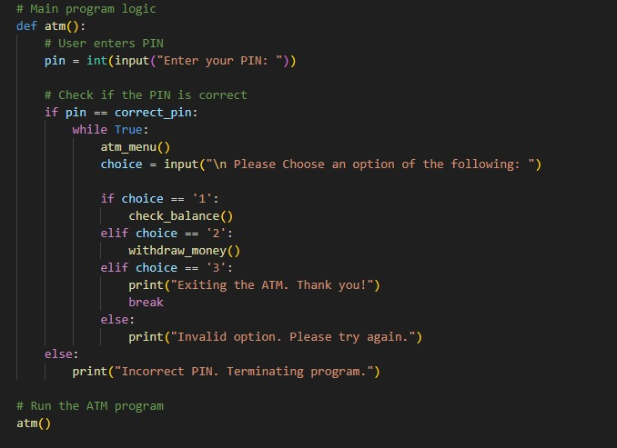

**OUTPUT:**

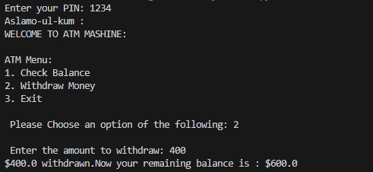

**Lab Task 2:**

Write a program that asks the user to enter a username and password.

● The correct username should be "admin" and the correct password should be the numeric value 12345.

● If both the username and password are correct, the program should display "Login Successful!".

● If the username is incorrect, display "Incorrect username".

● If the password is incorrect, display "Incorrect password".

**CODE:**

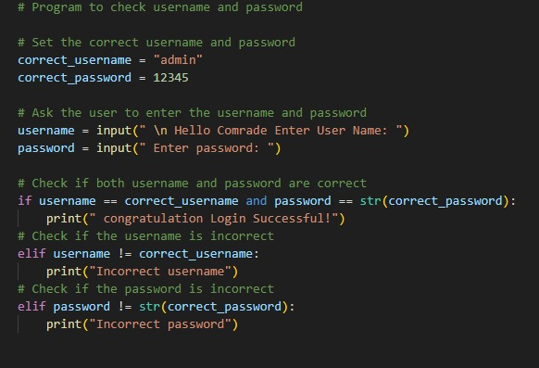

**OUTPUT:**

